

**A Project Report On**

**Online Education Platform**

**SUBMITTED BY**

**Shaikh Adnan**

**Syed Kashif Ali**

**Under the Guidance of**

**Ms Shafiya Sayyed**

**T.Y.B.C.A(Science)**

This Project Report is hereby presented to the esteemed Department of Computer application, signifying the satisfactory completion of the requirements for the Sem VI of Bachelor of Computer Application during academic year 2024-2025.

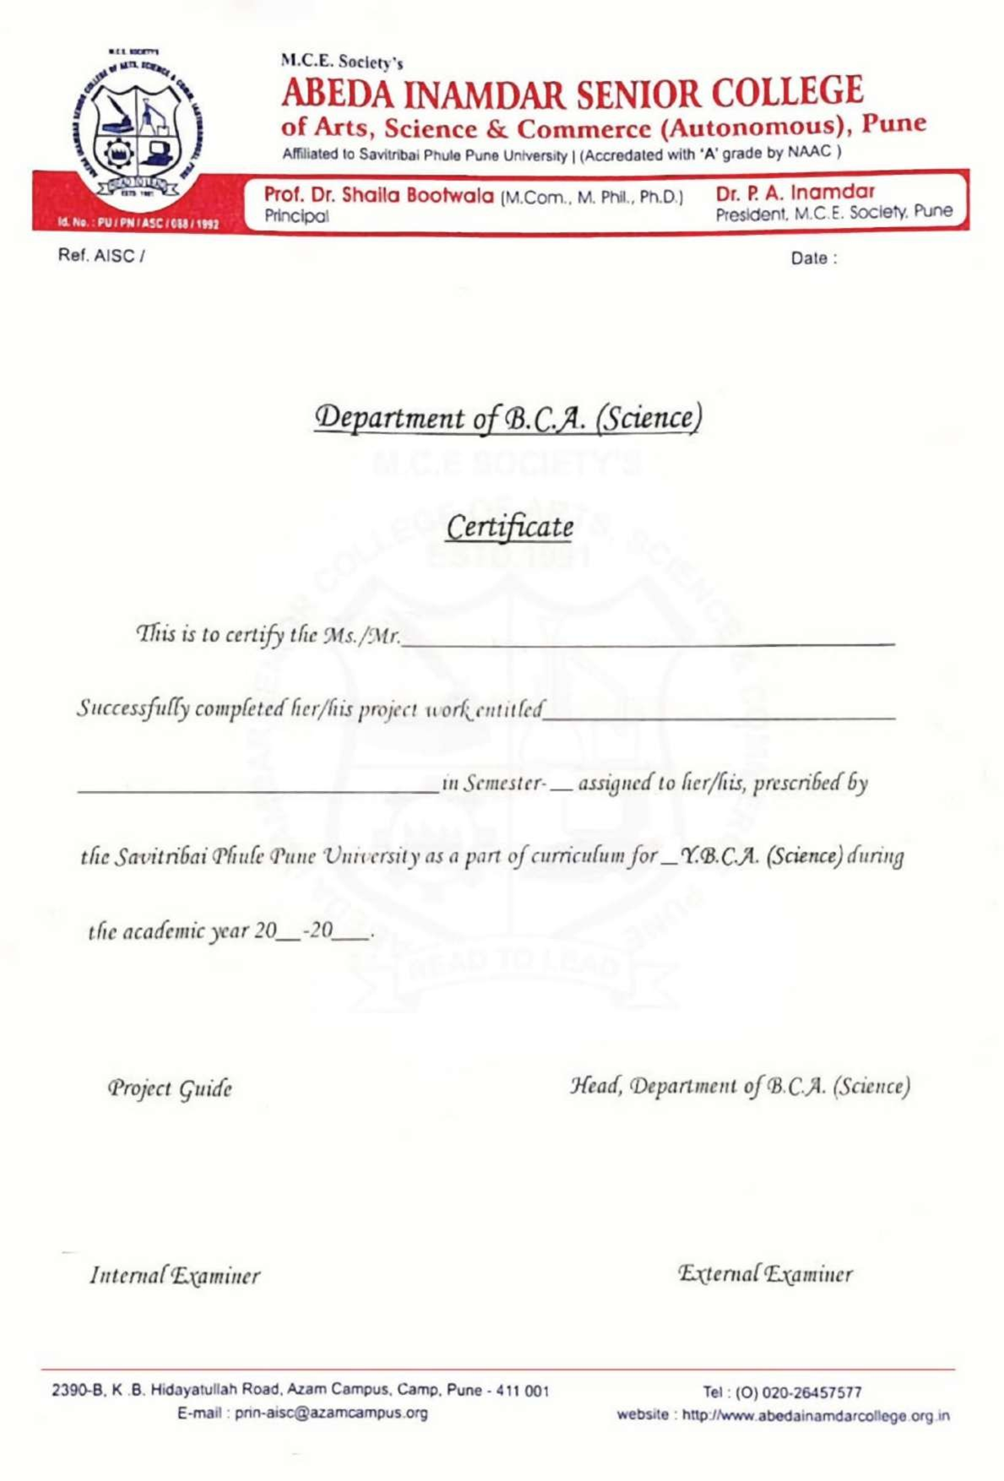

**Index**

|  |  |  |
| --- | --- | --- |
| **Sr.no** | **Topic** | **Page no.** |
| **1.** | **Acknowledgement** | **5** |
| **2.** | **Introduction** | **6** |
| **3.** | **Project Objectives** | **7** |
| **4.** | **Existing System** | **8** |
| **5.** | **Proposed System** | **9** |
| **6.** | **Project Scope** | **10** |
| **7.** | **Feasibility Study** | **11-12** |
| **8.** | **Hardware & Software** | **13** |
| **9.** | **System Design (ER, UML & DFD)** | **14-16** |
| **10.** | **Data dictionary** | **17-18** |
| **11.** | **Input & output screen** | **19-22** |
| **12.** | **Conclusion** | **23** |
| **13.** | **Bibliography** | **24-25** |

**Acknowledgement**

Online Education Platform would like to express my deepest gratitude to all those who have played a significant role in the development of this online education platform. First and foremost, I extend my sincere appreciation to the educators, instructors, and content creators whose dedication and expertise have enriched the platform with high-quality learning materials. I am also thankful to the development team for their hard work in designing a user-friendly and interactive system that enhances the learning experience. A special acknowledgment goes to the learners and users whose participation, feedback, and enthusiasm continue to drive improvements and innovations. Additionally, I would like to recognize the unwavering support from mentors, colleagues, and supporters who have provided valuable insights and encouragement throughout this journey. Finally, I acknowledge the power of technology and digital advancements, which have made it possible to create an inclusive, accessible, and flexible learning environment for individuals worldwide. Thank you all for your contributions and support in making this platform a success.

**INTRODUCTION**

An Online Education Platform serves as a virtual learning space where students, educators, and professionals can access a wide range of courses, tutorials, and learning materials. These platforms use advanced technologies such as artificial intelligence, interactive multimedia, and real-time collaboration tools to create an engaging and personalized learning experience. With features like live lectures, recorded sessions, assessments, discussion forums, and certification programs, they offer a flexible and cost-effective alternative to traditional education. Whether for academic learning, skill development, or professional training, online education platforms bridge the gap between learners and knowledge, making education more inclusive and accessible across geographical boundaries.

A special goes to the learners and users whose participation, feedback, and enthusiasm continue to drive improvements and innovations. Additionally, I would like to recognize the unwavering support from mentors, colleagues, and supporters who have provided valuable insights and encouragement throughout this journey.

**OBJECTIVE**

**Objectives of the Online Education Platform:**

1. **Provide Accessible Learning** – Ensure education is available to learners worldwide, regardless of location or background.
2. **Flexible Learning Experience** – Allow students to learn at their own pace with self-paced and instructor-led courses.
3. **Enhance Engagement** – Utilize interactive tools, multimedia content, and real-time collaboration to improve learning outcomes.
4. **Offer Diverse Courses** – Provide a wide range of subjects, from academic courses to professional skill development programs.
5. **Promote Lifelong Learning** – Encourage continuous education for personal and professional growth.
6. **Leverage Technology** – Use AI, automation, and data analytics to personalize learning experiences.
7. **Ensure Quality Education** – Deliver high-standard content with expert instructors and well-structured course materials.
8. **Facilitate Certification & Career Growth** – Offer certificates and training programs to help learners advance in their careers.
9. **Support Interactive Learning** – Enable discussions, peer collaboration, and mentorship through forums and live sessions.
10. **Make Education Affordable** – Provide cost-effective learning opportunities to a broad audience.

**EXISTING SYSTEM**

**Existing System of Online Education Platforms**

1. **Wide Range of Courses** – Platforms offer academic subjects, professional training, and skill-based learning.
2. **Multiple Teaching Methods** – Includes video lectures, quizzes, assignments, live sessions, and discussion forums.
3. **Popular Platforms** – Examples include Coursera, Udemy, edX, Khan Academy, and Moodle-based LMS.
4. **Self-Paced Learning** – Allows students to learn at their own convenience without strict schedules.
5. **Limited Personalization** – Most platforms lack adaptive learning to cater to individual student needs.
6. **High Course Costs** – Some courses and certifications are expensive, making them inaccessible for many learners.
7. **Technical Barriers** – Poor internet connectivity and lack of access to digital devices can be challenges.
8. **Limited Hands-on Practice** – Practical subjects often lack interactive or real-world application opportunities.
9. **Low Engagement Levels** – Lack of real-time interaction with instructors and peers can reduce motivation.
10. **Assessment Challenges** – Online exams

**NEED OF SYSTEM**

**Need for the Online Education Platform**

1. **Increased Accessibility** – Provides education to learners worldwide, overcoming geographical and financial barriers.
2. **Flexible Learning Options** – Allows students to learn at their own pace and schedule, making education more convenient.
3. **Affordable Education** – Reduces the cost of traditional education by offering budget-friendly or free courses.
4. **Personalized Learning Experience** – Uses AI and data analytics to adapt courses based on individual learning needs.
5. **Improved Engagement** – Incorporates interactive tools, gamification, and real-time discussions to enhance learning.
6. **Skill Development** – Helps students and professionals gain industry-relevant skills for career growth.
7. **Continuous Learning** – Encourages lifelong learning through easy access to diverse educational resources.
8. **Bridging the Digital Divide** – Provides opportunities for learners in remote and underprivileged areas.
9. **Efficient Assessment & Feedback** – Uses automated quizzes, AI-based grading, and instant feedback mechanisms.
10. **Scalability & Global Reach** – Can accommodate thousands of learners simultaneously without physical limitations.

**Project Scope**

**Project Scope of the Online Education Platform**

1. **User Accessibility** – The platform will be accessible to students, educators, and professionals worldwide, providing learning opportunities regardless of location.
2. **Course Variety** – It will offer a wide range of courses, including academic subjects, professional training, and skill-based programs.
3. **Flexible Learning Modes** – Supports self-paced learning, live classes, recorded sessions, and interactive content for better engagement.
4. **Multi-Device Compatibility** – The system will be available on desktops, tablets, and mobile devices for convenient access.
5. **Personalized Learning** – Implements AI-based recommendations to provide customized course suggestions and adaptive learning paths.
6. **Assessment & Certification** – Includes quizzes, assignments, and exams with certification upon course completion.
7. **Collaboration & Engagement** – Features discussion forums, peer interactions, and mentorship opportunities to enhance learning.
8. **Secure Payment Integration** – Offers various payment methods for premium courses and subscriptions.

**FEASIBILITY** **STUDY**

**Feasibility Study for the Online Education Platform**

A feasibility study evaluates the practicality of developing and implementing the online education platform by analyzing various factors, including technical, economic, operational, legal, and schedule feasibility.

**1. Technical Feasibility**

* Utilizes modern web and mobile technologies to develop an interactive and scalable platform.
* Supports multi-device compatibility (PC, tablets, and mobile).
* Implements cloud-based storage for course content and user data.
* Incorporates AI-driven personalization, real-time collaboration tools, and secure payment gateways.
* Ensures security through encryption, authentication, and data protection mechanisms.

**2. Economic Feasibility**

* Reduces traditional education costs by providing online learning resources.
* Requires an initial investment in software development, server hosting, and content creation.
* Revenue generation through subscription plans, course purchases, advertisements, and partnerships.
* Cost-effective compared to physical classrooms, reducing infrastructure expenses.
* High return on investment (ROI) due to the growing demand for e-learning solutions.

**3. Operational Feasibility**

* Designed for ease of use, with an intuitive UI/UX for students, educators, and administrators.
* Supports automated course management, progress tracking, and assessments.
* Offers real-time support and feedback mechanisms to enhance user experience.
* Includes a well-structured admin panel for efficient course and user management.

**4. Legal Feasibility**

* Complies with data protection regulations such as GDPR and other privacy laws.
* Ensures copyright compliance for course content and materials.
* Follows legal requirements for online transactions and payment security.

**5. Schedule Feasibility**

* The development timeline is planned in phases, including requirement analysis, design, development, testing, and deployment.
* Can be launched as an MVP (Minimum Viable Product) initially and scaled with advanced features over time.
* Regular updates and improvements will ensure platform efficiency and adaptability to new educational trends.

### **Conclusion**

The feasibility study confirms that the online education platform is technically viable, economically profitable, operationally efficient, legally compliant, and can be developed within a reasonable timeframe. With the growing demand for e-learning, this platform has a strong potential for success and long-term sustainability.

**Hardware & Software**

**Hardware Requirements:**Processor: Intel® Core™ i3-6100T CPU@3.20GHz,

3192MHz, 2Core(s), 4 Logical Processor(s).

RAM: 8.00GB.

**Software Requirements:**

Operating System: Windows 7, 8.1, 10, 11

Visual Studio Editor

PostgreSQL (MySQL) and PostgreSQL Driver

Localhost 3306 Server

**System Design**

**(ERD&DFD)**

* ER-diagram:

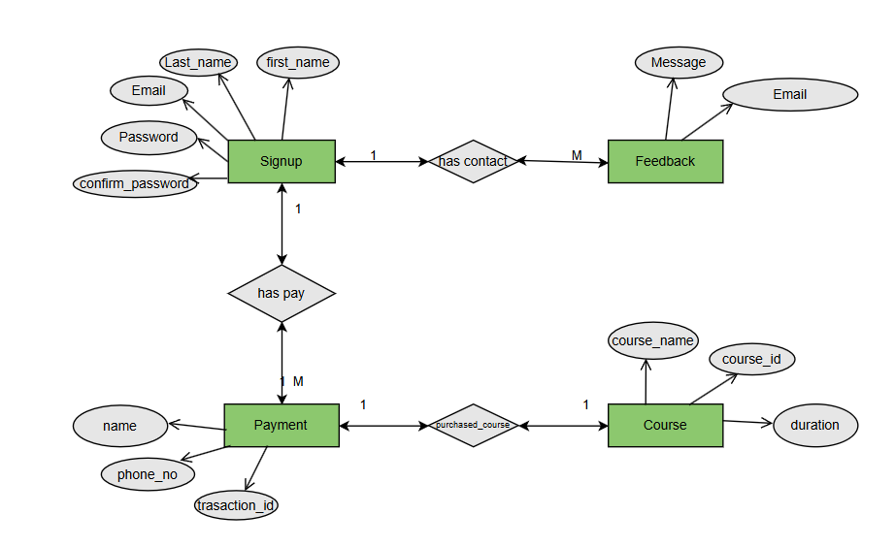

**DFD (LEVEL 0)**

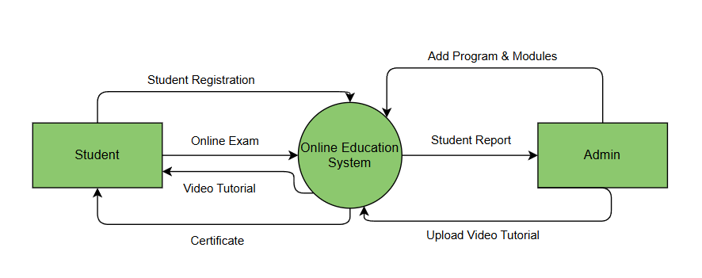

**DFD (LEVEL 1)**

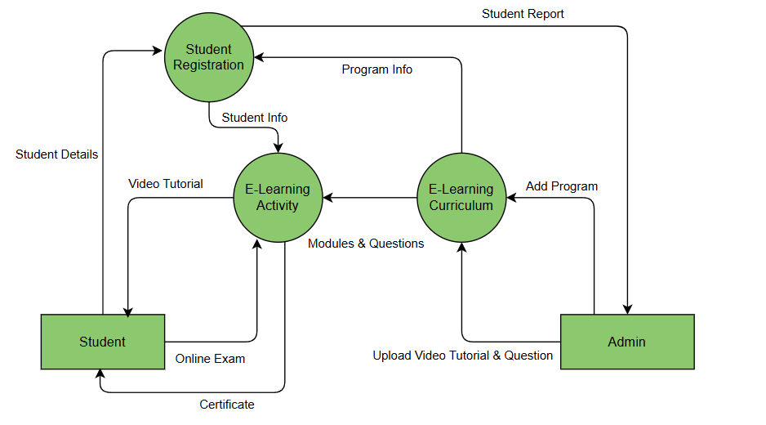

**DFD (LEVEL 2)**

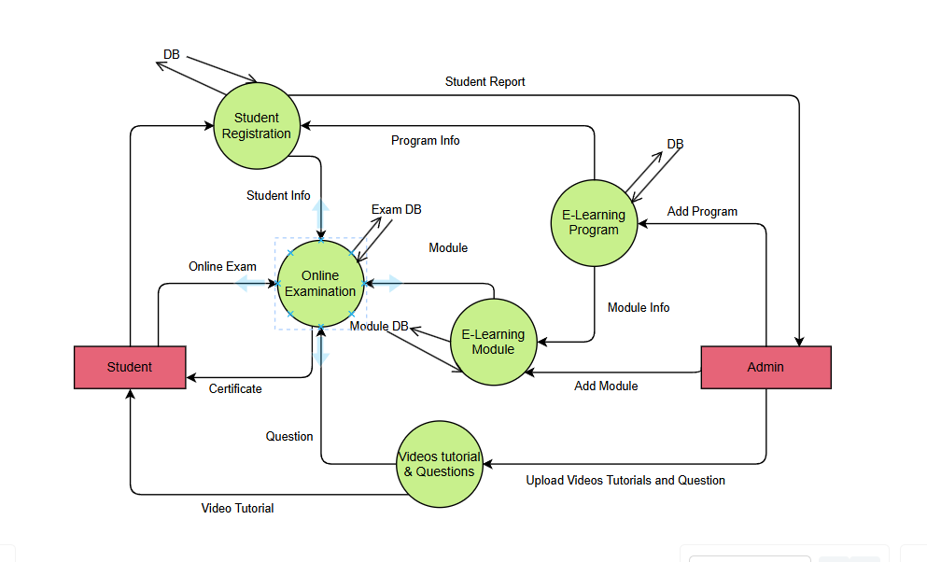

**Data Dictionary**

**Here we have different Entities such as Signup,Feedback,Payment,Course. Detail info about the**

**Entity as follows:**

**Table: Signup**

**First_name (primary key): A unique identifier for each course**

**Data Type: String(Varchar)**

**Last_name : The Name of User and Title**

**Data Type: String(Varchar)**

**Email (primary key): A Email of the User**

**Data Type: String(Varchar)**

**Password : A security password for User**

**Data Type: String(Varchar)**

**Confirmed_Password : A security Confirmed_password for User**

**Data Type: String(Varchar)**

**Table: Feedback**

**Email: A email is used to add mail of user**

**Data Type: String(Varchar)**

**Message (primary key): A message of reporting and feedback**

**Data Type: Varchar**

**Table: Course**

**Course_id (primary key): counting the number of Courses**

**Data Type: Integer(int)**

**Course_name : The name and Title of Course.**

**Data Type: String(Varchar)**

**Duration : A time of Course ending.**

**Data Type : String(Varchar)**

**Table: Payment**

**Name (Primary key) : Name of the User who Paid.**

**Data Type : String(Varchar)**

**Phone no: Mobile number of User who Paid.**

**Data Type :Integer (int)**

**Transaction_id : transaction Id of User who Paid.**

**Data Type : String(Varchar)**

**Website Layout**

* Home page.

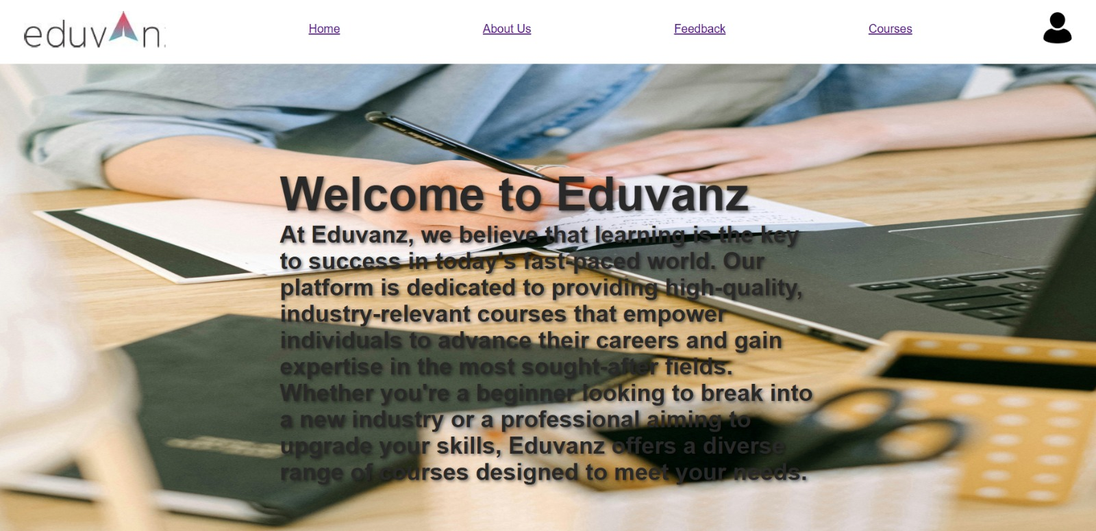

**Registration & Login**

* Registration Page.

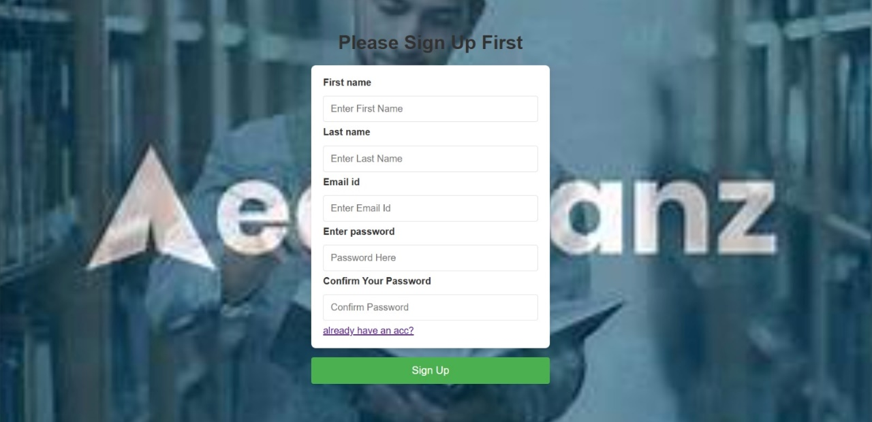

* Login Page.

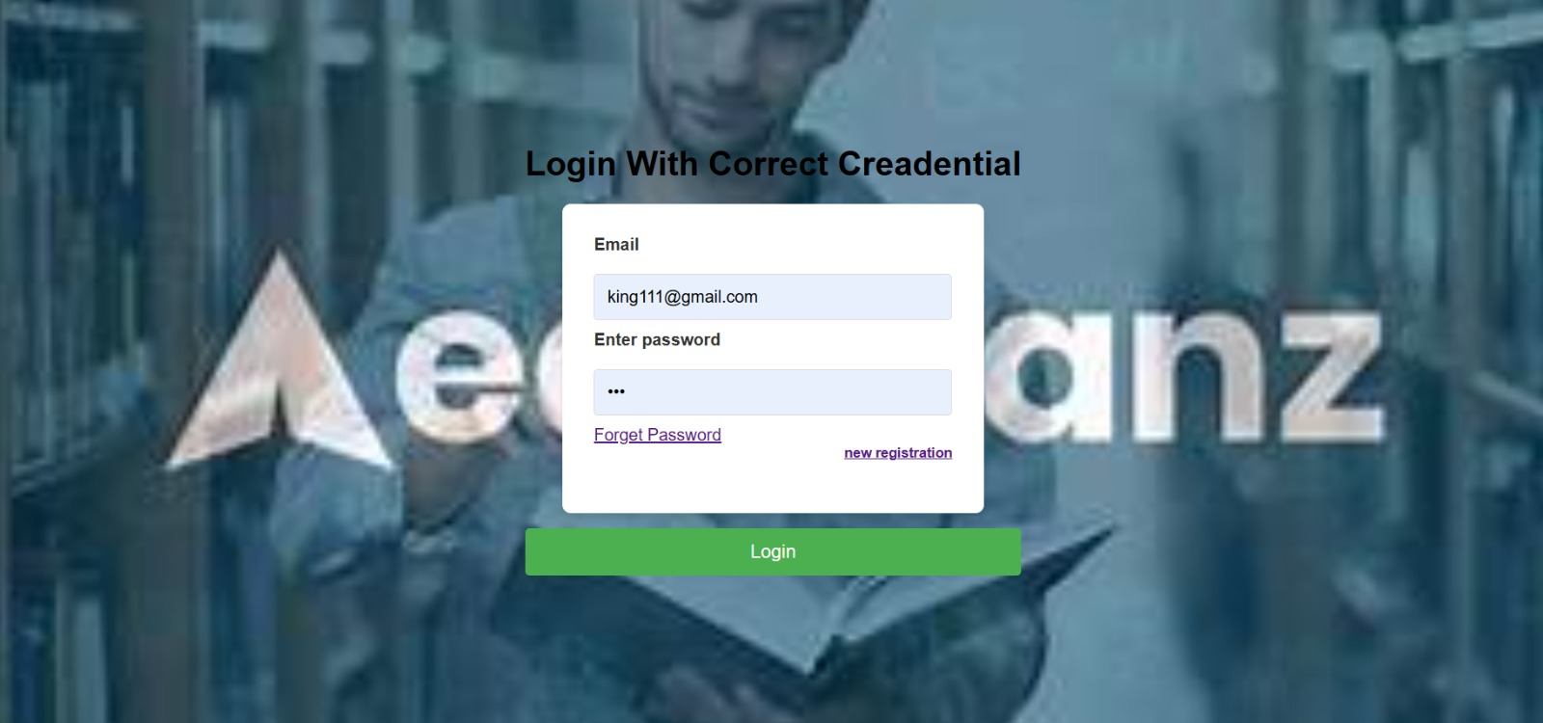

**Videos And Tutorials**

* Module Page.

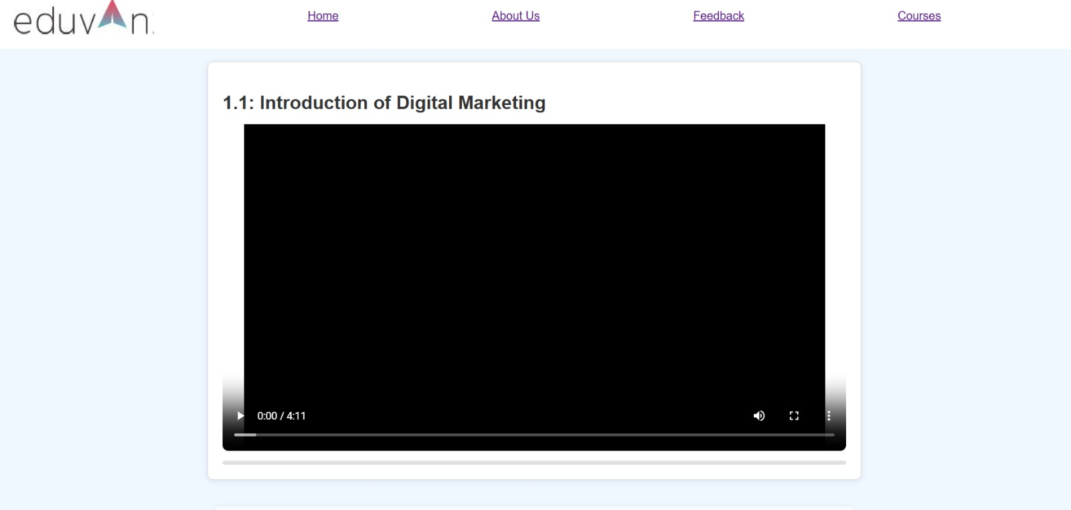

* Feedback page

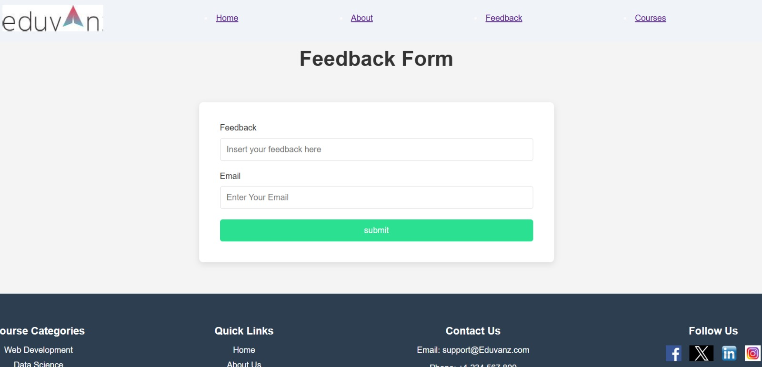

*

**Course Page**

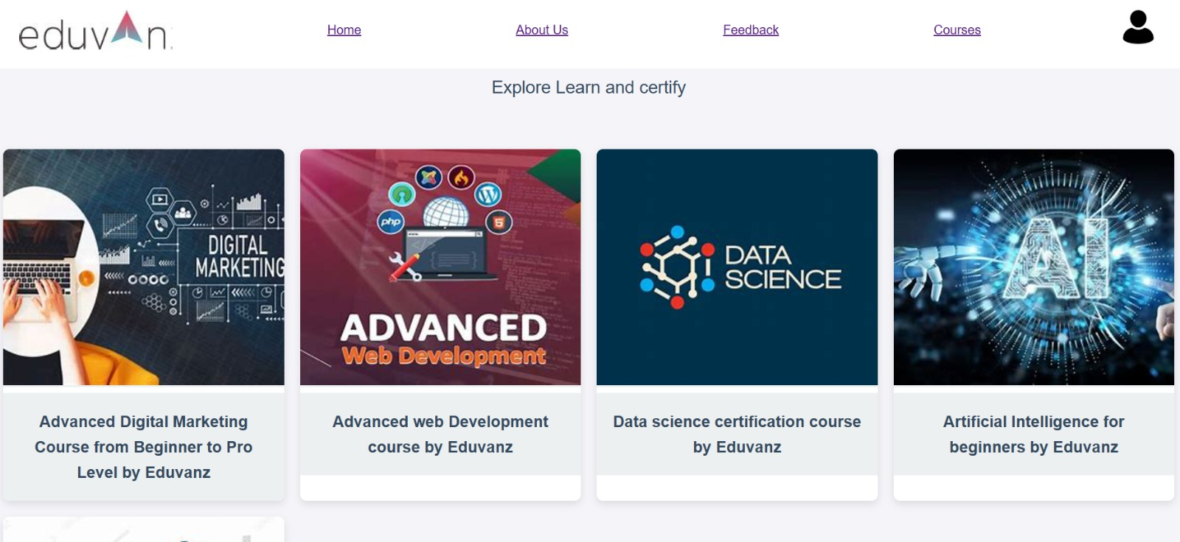

**Conclusion**

The development of an online education platform is a significant step toward making learning more accessible, flexible, and engaging for a global audience. By leveraging modern technology, the platform offers a diverse range of courses, interactive learning tools, and personalized experiences to meet the needs of students, educators, and professionals. It overcomes traditional education barriers by providing cost-effective, scalable, and user-friendly solutions.

Through a detailed feasibility study, it is evident that the platform is technically viable, economically sustainable, and operationally efficient. With continuous improvements and innovations, it has the potential to revolutionize education, bridge the knowledge gap, and promote lifelong learning. Ultimately, this platform will contribute to the advancement of digital education and empower individuals to achieve their academic and career aspirations.

**Bibliography**

1. PHP Documentation.

<https://www.php.net/docs.php>

For php programming language referred this documentation.

PHP (Hypertext Preprocessor) is a widely-used open-source scripting language primarily designed for web development. It runs on the server side and is embedded in HTML to create dynamic web pages. PHP is commonly used for developing websites, web applications, and content management systems (CMS) like WordPress, Drupal, and Joomla.

**Key Features of PHP:**

* **Server-Side Execution**: PHP code runs on the server and generates HTML for the browser.
* **Easy to Learn**: Simple syntax, especially for those familiar with C, Java, or JavaScript.
* **Database Integration**: Works well with databases like MySQL, PostgreSQL, and SQLite.
* **Cross-Platform**: Runs on Windows, macOS, Linux, and various web servers.

1. GitHub.

<https://github.com/>

For reference work we use GitHub.

• **version Control** – Tracks changes in code using Git.

• **Collaboration** – Multiple developers can work on the same project.

• **Repositories** – Store project files in public or private repositories.

• **Branching & Merging** – Work on different features without affecting the main code.

• **Pull Requests** – Review and suggest changes before merging.

• **Issues & Project Management** – Track bugs, tasks, and enhancements.

1. MySQL.

<https://www.mysql.com/>

The MySQL documentation was used extensively for database design and management.

**MySQL - Key Highlights**

* **Relational Database** – Uses Structured Query Language (SQL) for managing data.
* **Open-Source** – Free to use with an active community (owned by Oracle).
* **High Performance** – Optimized for speed and scalability.
* **Cross-Platform** – Works on Windows, Linux, macOS, and cloud environments.
* **ACID Compliance** – Ensures reliability with transactions.
* **Replication & Clustering** – Supports data replication and high availability.

1. CSS.

<https://developer.mozilla.org/en-US/docs/Web/CSS>

This reference is mostly used for the attractive and responsive web layout.

**CSS (Cascading Style Sheets) - Key Highlights**

* **Styling** – Defines colors, fonts, and layouts for web pages.
* **Responsiveness** – Ensures mobile-friendly and adaptive designs.
* **Selectors & Properties** – Targets specific HTML elements for customization.
* **Box Model** – Controls padding, margins, and borders.
* **Flexbox & Grid** – Simplifies complex layouts with flexible positioning.
* **Animations & Transitions** – Enables smooth visual effects.
* **Media Queries** – Adjusts styles based on screen size and resolution.
* **Custom Variables (CSS Variables)** – Improves maintainability and consistency.